Project Design Phase

Solution Architecture
Date | 19 September 2026
Team ID | Shaik Irshad - 238W1A4256
Project Name | Automated Network Request Management In ServiceNow
Maximum Marks | 4 Marks

Solution Architecture
Solution architecture bridges the gap between the business problem and the technology solution. For this project, its goals were to:
- Find the best-fit ServiceNow-native mechanism to solve the network-request problem described in the Problem Statement.
- Describe the structure, components and behaviour of the solution for project stakeholders.
- Define the features and components actually delivered (see Section 38 of the project's authoritative feature list) rather than aspirational ones.
- Provide a clear specification of how the request flows through the system, from submission to final Approved/Rejected status.

Solution Architecture Diagram:
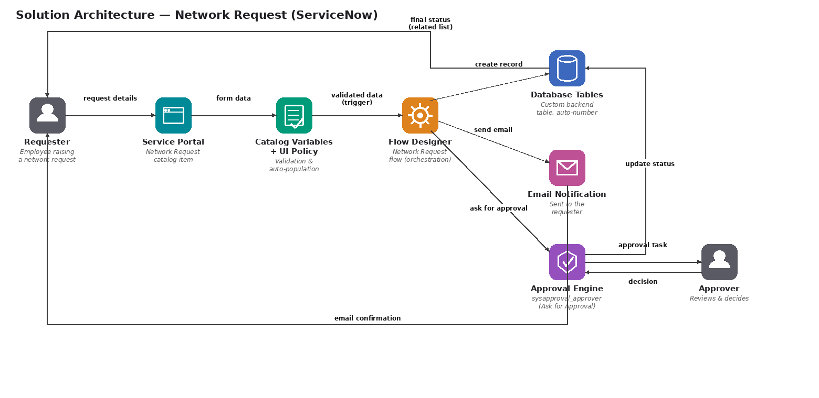
Figure 1: Architecture and data flow of the Network Request ServiceNow application
Component Notes
- Requester / Approver: the two human actors; both interact only through the standard ServiceNow Service Portal and native notification/approval mechanisms — no separate app was built for either.
- Service Portal (Network Request catalog item): the single entry point; hosts the catalog variables and enforces mandatory fields.
- Catalog Variables + UI Policy (+ Variable Set): validates required fields, dynamically shows/hides the Existing ID field, and auto-populates requester details — entirely configuration, no client scripts.
- Flow Designer: the orchestration layer that reads the submitted variables, creates the backend record, sends the email, raises the approval, and updates the final status — replacing what would otherwise need custom Business Rules or Script Includes.
- Database Tables: the custom backend table holding one record per request, with an auto-generated Database Number and an Approval Status field.
- Approval Engine: ServiceNow's native sysapproval_approver mechanism, configured with an “Anyone approves” rule and a single approver used during testing (not a multi-level manager/security hierarchy).

